28.19:

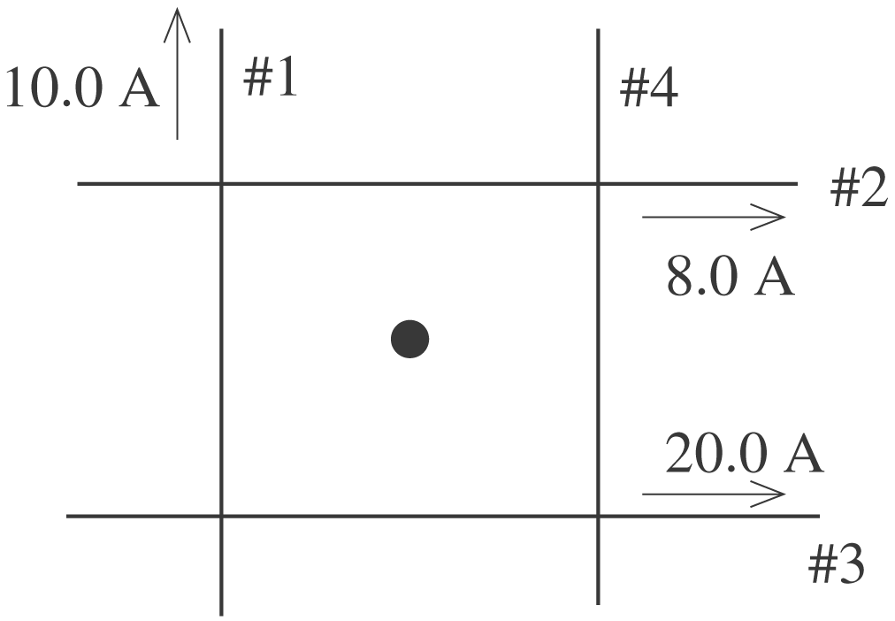 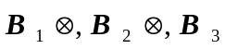⊙
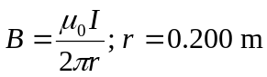 for each wire

Let ⊙ be the positive z-direction. 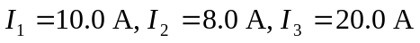
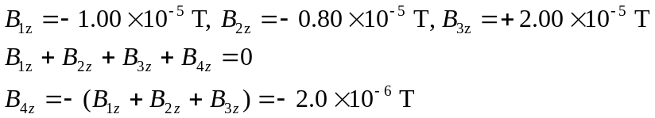
To give 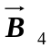 in the  direction the current in wire 4 must be toward the bottom of the page.
